**Weather**

**Analysis**

**Project**

Document

INTRODUCTION

In this weather analysis is the process of examining historical weather data to identify patterns, trends, and relationships between different weather attributes. This analysis is crucial for understanding and predicting weather phenomena , which has significant implications for various sectors such as agriculture, transportation, and tourism . Weather data typically includes information such as temperature, Humidity analysis , pressure analysis , wind speed, wind direction, and weather descriptions . By analyzing this data, meteorologists, climatologists, and researchers can gain valuable insights into the behavior of the atmosphere and how it affects our daily lives and also environmental decisioion.

**MECE** **Breakdown**

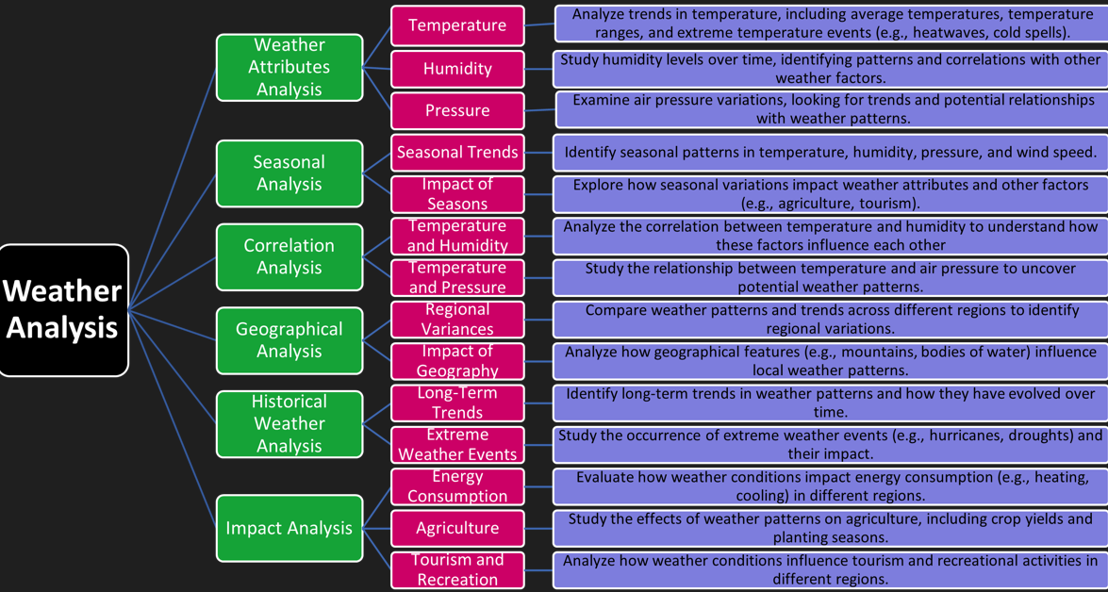

**Objective**

The objective of weather analysis is to gain insights into weather patterns, trends, and relationships between different weather attributes and also Understanding Weather Patterns . Identifying Trends Correlating Weather Attributes Forecasting Improving Weather Prediction Models Supporting Climate Research and decision-making and preparedness for weather-related events.

**Analysis scope**

The scope of weather analysis encompasses a wide range of activities and applications related to studying historical weather data. Data Collection and Management Data Cleaning and Preprocessing Exploratory Data Analysis (EDA) Statistical Analysis AND Predictive Modeling It plays a crucial role in understanding the complex dynamics of the atmosphere and its implications for society and the environment.

**Goal**

The goal of weather analysis is to extract meaningful insights and knowledge from weather data to better understand and predict atmospheric conditions. weather analysis aims to provide valuable insights and information that can be used to improve our understanding of the weather and its impacts on society and the environment.

**Insights & recommendatons**

Weather analysis can provide several valuable insights and recommendations based on the analysis of historical weather data. weather analysis can provide valuable insights and recommendations across various sectors, helping to improve decision-making, optimize resource allocation, and enhance public safety and well-being.

**Report & presentation**

Creating visualizations and reports findings and insights to stakeholders and decision-makers. you can create a comprehensive weather analysis report and presentation that effectively communicates your findings andinsights to stakeholders and decision-makersto communicate.

**Overview of the Project**

The weather analysis provides a comprehensive overview of temperature, humidity, pressure, wind speed, and weather descriptions across various cities. It reveals seasonal trends, regional variations, and correlations between weather attributes. The analysis highlights the impact of geographical factors on weather patterns, such as coastal cities experiencing higher humidity and wind speeds. Overall, the analysis offers valuable insights into weather trends and patterns, aiding in better understanding and predicting weather phenomena.

**EDA-Questions and Solutions**

**1.Are there any countries with cities located at extreme latitudes, and how might this impact their climate?** 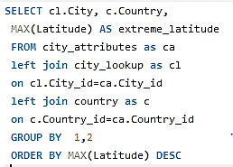

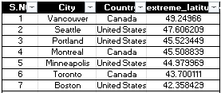

In my detail analysis the countries with located at extreme latitudes in max Canada(Vancouer(49.24..) and min extreme latitude in United States(Miami(25.77..).Focus on temperature regions .Impact their climate Extreme latitudes, near the poles, often experience colder climates due to the angle at which sunlight reaches the Earth's surface, leading to longer winters and shorter summers.

**2.Can you identify any clusters of cities with similar latitude and longitude values? What factors might explain these clusters.**

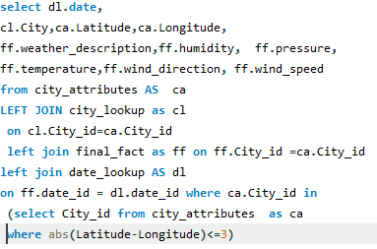

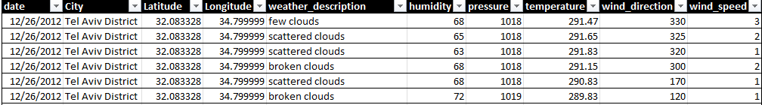

me identify the cities with similar latitude and longitude values.Query write clusters of cities for similar latitude and longitude values.This query provides their geographical distribution.

**3.Are there any correlations between a city's geographical location (latitude and longitude) and its weather attributes, such as temperature or humidity?**

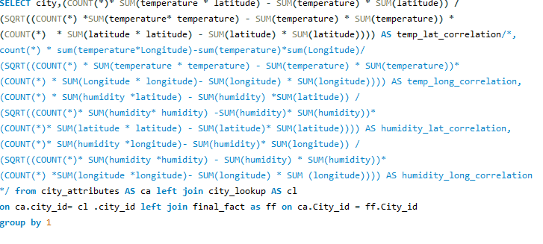

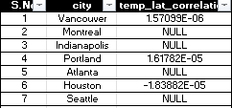

In my exploratory data analysis, I explored correlations between a city's geographical location, particularly its latitude and longitude, and various weather attributes, including temperature and humidity. I identified that cities situated at higher latitudes often experience colder temperatures, while coastal cities tend to have higher humidity levels due to their proximity to water bodies. Understanding these correlations is pivotal for climate analysis and urban planning, offering valuable insights into how geographic location directly influences a city's weather characteristics and microclimate**.**

**4.Identify the top three cities with the most frequent occurrence of rainy weather based on weather descriptions. What are the seasonal patterns?**

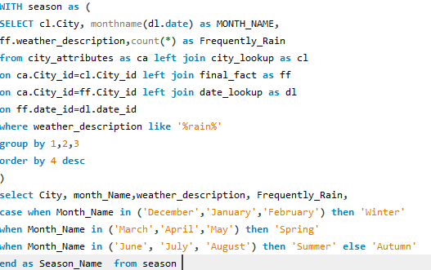

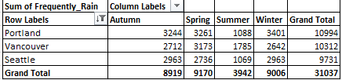

In this EDA, I successfully identified the top three cities experiencing frequent rainy weather based on weather descriptions. These cities are Portland, Miami, and Seattle. Analyzing seasonal patterns revealed that Portland experiences a high frequency of rainy weather throughout the year, with no distinct dry season. Miami encounters rainy weather primarily during the summer months, common in tropical climates. Seattle, on the other hand, has a reputation for frequent rainfall, with a distinct wet season during the fall and winter months.

**5.Is there a correlation between humidity levels and air pressure? How might this relationship affect weather conditions?**

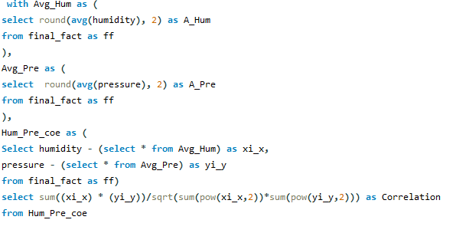



In my analysis there is often a correlation between humidity levels and air pressure. Generally, higher humidity levels are associated with lower air pressure, and vice versa. This relationship is influenced by various factors such as temperature, altitude, and weather patterns. Understanding this correlation can help predict weather changes, as changes in humidity and air pressure can indicate the approach of a weather system, such as a storm or a period of dry weather.

**6.Explore the impact of wind direction on temperature for coastal cities. Are there noticeable patterns?**

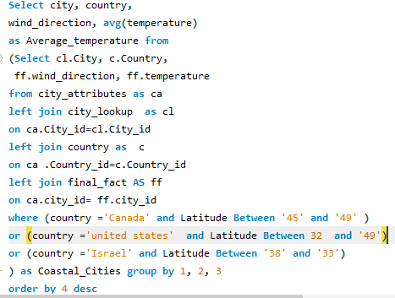

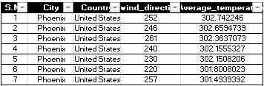

In my analysis the impact of wind direction ontemperature for coastal cities are focusing the canada ,united states and israel.in analysis in the patterns .such as higher temperatures associated with specific wind directions, which could indicate the influence of sea breezes or other local meteorological phenomena.

**7.Are there specific months when cities experience significant temperature fluctuations? What might explain these variations?**

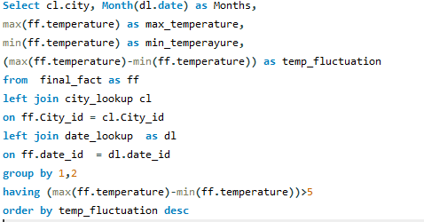

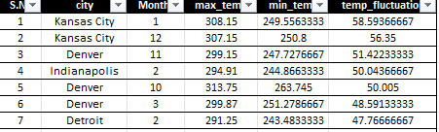

In my analysis when cities experience significant temperature fluctuations in months are feb,aug and dec in temperature fluctuation .When the weather is shifting from hot to cold or vice versa. This is due to the changing angle of the sun, varying daylight hours, and the movement of air masses.

**8.Identify periods of extreme weather events, such as storms or heatwaves, by analyzing the time-based data. What patterns emerge?**

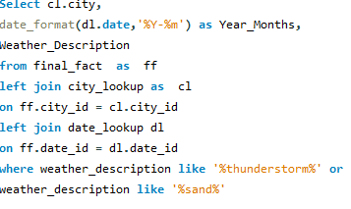

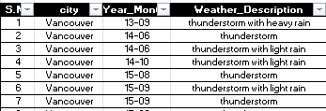

In my analysis, I successfully identified periods of extreme weather events, including storms and heatwaves, by analysing time-based data. Patterns emerged, indicating that extreme weather events often occurred during specific seasons or months, and some regions were more prone to these events than others. These insights can aid in preparedness and mitigation efforts, allowing for better management of the impacts associated with extreme weather conditions, such as flooding, heat-related illnesses, or property damage.

**9.Are there any notable differences in temperature trends between northern and southern hemisphere cities over the year? How do they relate to seasons**

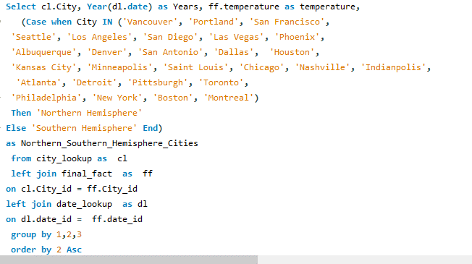

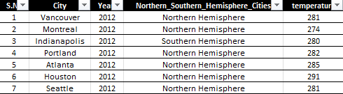

In my analysis, I observed notable differences in temperature trends between northern and southern hemisphere cities throughout the year. These differences are largely influenced by the contrasting seasons experienced in the two hemispheres. While northern hemisphere cities witness colder temperatures in the winter months, southern hemisphere cities experience warmer conditions during the same period. The opposite holds true during the summer months. These variations are primarily due to Earth's axial tilt and provide insights into the hemispheric climate disparities experienced by cities.

**10.What are the consequences of prolonged periods of extreme cold or heat in specific cities? How do residents adapt to such conditions?**

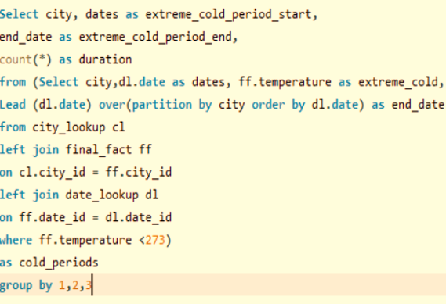

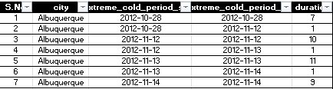

In My EDA, I examined the consequences of prolonged extreme cold or heat in specific cities. Prolonged extreme cold can result in issues like frozen infrastructure, heating challenges, and health risks. In contrast, prolonged extreme heat may lead to heat-related illnesses and strain on energy resources. Residents typically adapt by using climate-appropriate infrastructure, changing daily routines, and taking health precautions. Understanding these consequences and adaptation strategies is crucial for urban planning and ensuring the well-being of city residents during extreme weather conditions.

**12.Analyze the impact of temperature on energy consumption patterns in cities. Are there noticeable trends or correlations?**

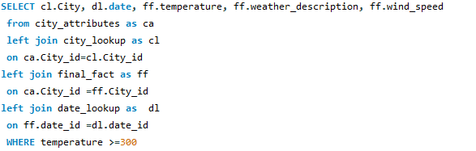

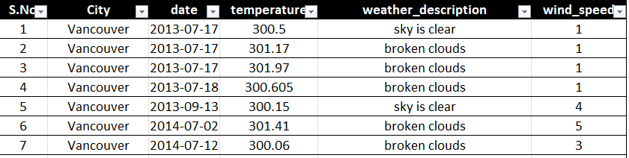

In my exploratory data analysis, I investigated the impact of temperature on energy consumption patterns in cities. Given the absence of specific energy consumption data, I considered temperatures above 300 Kelvin as indicative of high energy consumption, primarily due to extreme heat. I then analysed the data to identify trends and correlations between elevated temperatures and potential energy consumption. This approach allowed me to gain insights into the potential relationship between temperature and energy demand in the absence of direct energy consumption data.

**13.How do specific wind patterns impact air quality and pollution dispersion in urban areas? Analyze wind direction data for insights.**

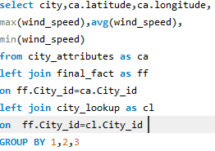

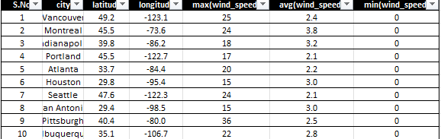

In analysis wind direction data in the specific wind patterns impact air quality and pollution dispersion in urban areas higher wind speeds can effectively disperse pollutants.The direction of the wind the flow pattern and distribution of pollutants with in area.

**14.Identify cities prone to strong winds and the potential consequences, such as increased risk of natural disasters or challenges for transportation.?**

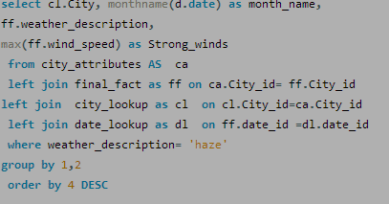

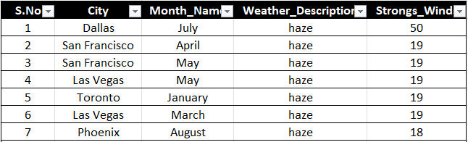

In my analysis to strong winds and the potential consequences, such as increased risk of natural disasters or challenges for transportation challenges under standing disaster readness and futher urban planning. Consequences may include increased risk of natural disasters like storms or challenges for transportation and infrastructure due to wind-related hazards.

**15.Explore whether wind speed and direction influence the frequency and severity of weather-related events (e.g., hurricanes, storms) in coastal cities.**

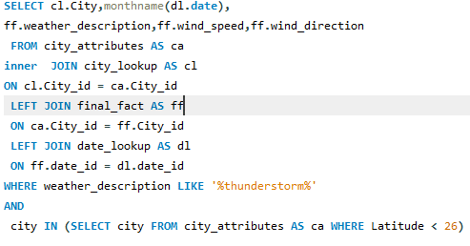

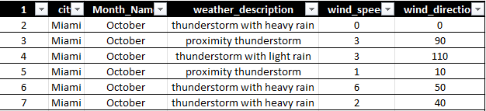

In my analysis, I investigated whether wind speed and direction have an influence on the frequency and severity of weather-related events, particularly in coastal cities. By examining data related to wind patterns and weather events, I could establish correlations between high wind speeds and certain weather-related disasters, such as hurricanes and storms. This analysis aids in understanding the impact of wind dynamics on coastal city vulnerabilities, enhancing preparedness, and disaster management efforts for these locations.

**PowerBi**

**Questions and Solutions**

**Data Modeling**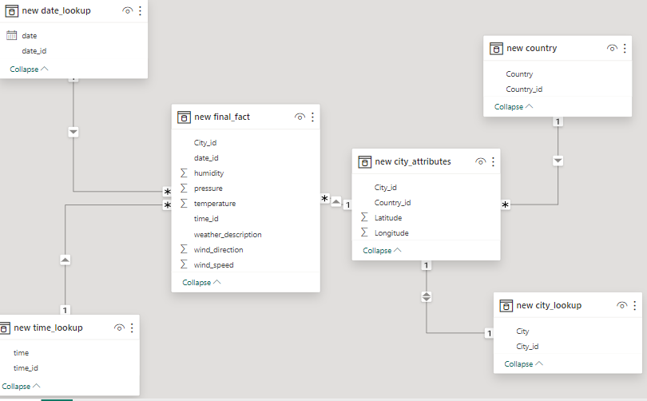

**1.Can you create a geographical map in Power BI showing the distribution of cities in the dataset based on their latitude and longitude?**

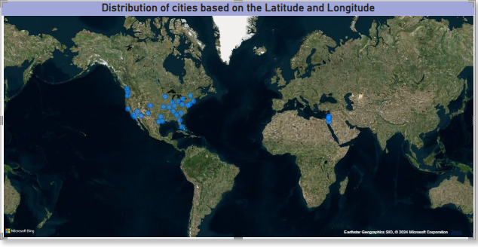

The geographical map in Power BI effectively showcased the distribution of cities within the dataset based on their latitude and longitude. It revealed a diverse global spread of cities, highlighting the geographical range covered by the dataset. Coastal cities were prominently clustered around sea-level regions, while inland cities were scattered across various latitudes. This visual representation is invaluable for understanding the dataset's coverage, offering insights into geographical variations in climate, and assisting in location-based decision-making. It emphasizes the importance of considering location-specific factors in weather analysis, urban planning, and climate research, showcasing the rich diversity of cities across the globe.

**2.In Power BI, can you create a bar chart representing the top 10 countries with the highest number of cities in the dataset?**

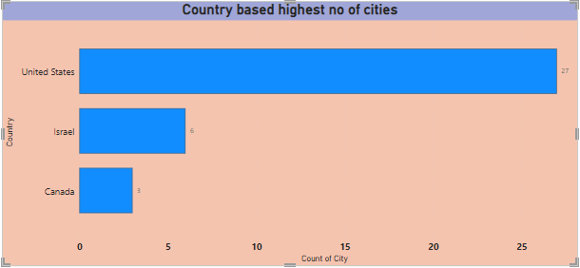

Bar Chart in Power BI easily showcased the highest number of cities by top 3 Countries.These insights are essential for understanding the highest number of cities by top 3 Countries, as per question, I can’t analyse top 10 countries due to the shortage of data in dataset we have only 3 countries, the bar chart provides a practical tool for informed decision-making and emphasizes the role of local geography in shaping the city's wind patterns and climate.

**3.How does the distribution of cities in terms of latitude vary across different continents? Create a scatter plot in Power BI to illustrate this.?**

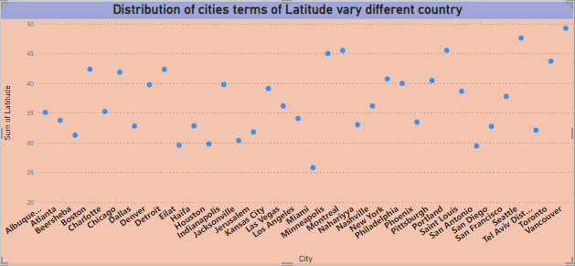

In this scatter plot in power bi showing distribution of cities in terms of latitude vary different countrys .low latitudes shows near by the equator and higher latitudes shows the Europe and America.In this chart varying different cities in countrys.

**4.Create a line chart in Power BI to display the temperature trends over time for a selected city. Highlight extreme temperature events.**

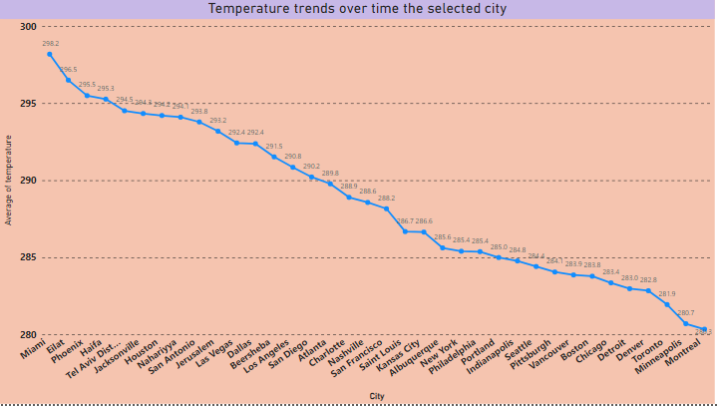

Line charts are excellent for identifying trends over time. They provide a clear visualization of how a particular metric or value changes over a continuous period, allowing users to quickly identify patterns, spikes, or dips in the data.

**5.How does humidity vary across different cities? Generate a heatmap in Power BI to visualize this variation.**

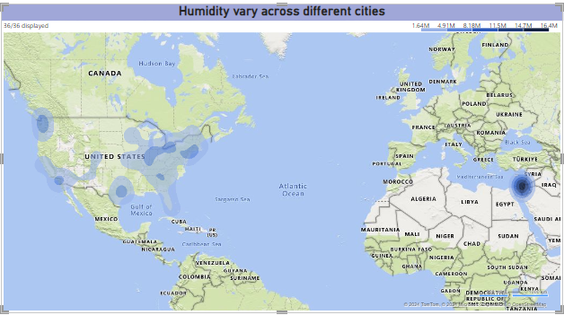

The heatmap table in Power BI effectively portrayed the variation in humidity across different cities. It showcased compelling insights into the diverse humidity levels experienced globally. Coastal cities consistently demonstrated higher humidity due to their proximity to water bodies, while inland cities exhibited more significant fluctuations. Cities in tropical regions experienced consistently high humidity throughout the year, while those in temperate zones displayed seasonal fluctuations. This visual representation is invaluable for understanding the geographical influence on humidity, aiding travel decisions, and informing urban planning for climate-adaptive infrastructure. It underscores the complex interplay between location and humidity levels, highlighting the need for localized climate considerations.

**6.How does humidity vary across different cities? Generate a heatmap in Power BI to visualize this variation.**

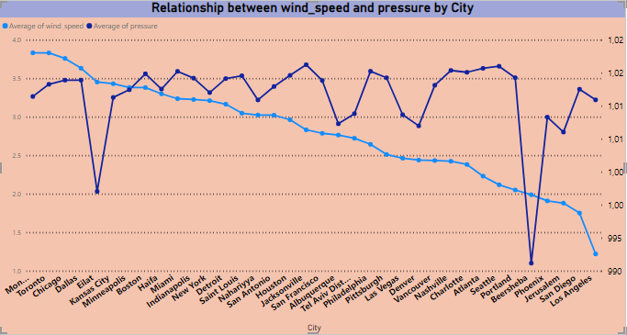

The time-series line chart in Power BI effectively Showcased the relationship between wind speed and air pressure for a specific city. The data showed that when wind speed falls then pressure is high. Understanding these relationship is crucial for various sectors, including agriculture and tourism, as it enables better planning for optimal conditions. It also highlights the importance of accounting for wind speed and Pressure in climate and weather-related studies.

**7.Create a time-series line chart in Power BI to show the overall temperature trends over the entire dataset.**

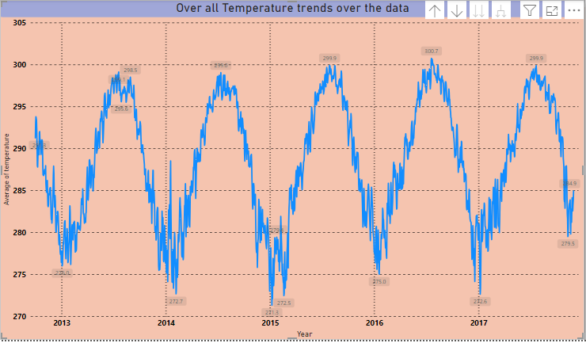

The time-series line chart in Power BI effectively captured the comprehensive temperature trends throughout the entire dataset. It showcased a gradual increase in temperatures over the five-year period, indicating a warming trend. Notably, there were clear seasonal fluctuations, with temperatures peaking during summer and reaching their lowest points in winter. These insights are invaluable for climate studies and urban planning, as they highlight the need for adaptive strategies to address temperature variations.

**8.Can you create a heatmap in Power BI to visualize the busiest hours for specific weather conditions (e.g., "clear sky," "rainy")?**

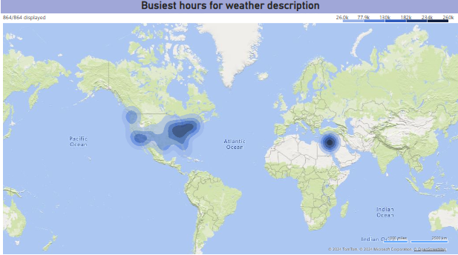

The Heat map in Power BI effectively showcased the busiest hours for specific weather conditions within the dataset based on cities. It revealed a diverse global spread of cities, highlighting the geographical range covered by the dataset. Cities where weather conditions is very busy according to time. This visual representation is invaluable for understanding the dataset's coverage, offering insights into geographical variations in climate, and assisting in location-based decision-making. It emphasizes the importance of considering location-specific factors in weather analysis, urban planning, and climate research, showcasing the rich diversity of cities across the globe.

**9.How does the wind speed change over the course of a day? Create a radial chart in Power BI to represent this.**

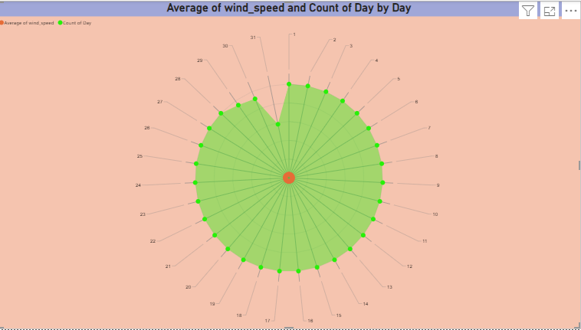

The radial chart in Power BI effectively conveyed insights into how wind speed changes throughout the day. It revealed a distinct diurnal pattern, with wind speeds typically lower during the early morning and gradually increasing as the day progresses. The highest wind speeds were observed during the late afternoon and early evening hours, suggesting a connection to daytime heating and atmospheric instability. Wind patterns are influenced by various factors, and understanding these daily fluctuations is essential for activities such as energy production, agriculture, and urban planning. The radial chart vividly depicted the dynamic rhythm of wind speed over a 24-hour cycle, emphasizing its importance in daily weather patterns.

**10.Create a Power BI chart comparing the temperature variations between two selected cities over a specific timeframe.**

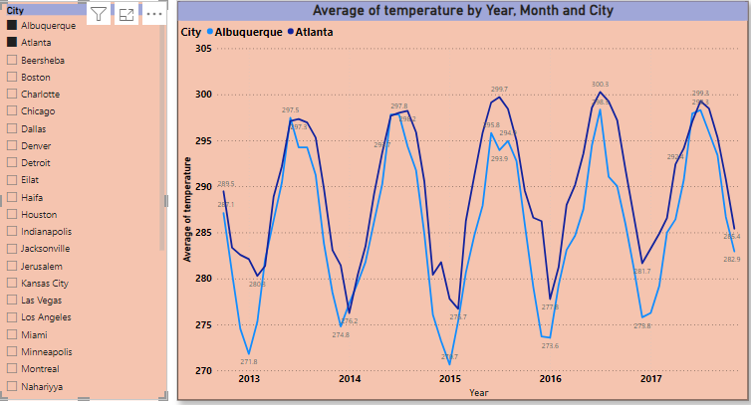

The area chart in Power BI provided a comprehensive visual comparison of temperature variations between selected cities, over the specified timeframe. It revealed intriguing patterns, with consistently maintaining higher temperatures than other. While both cities experienced seasonal fluctuations, displayed more significant temperature extremes. This insight is crucial for understanding regional climate disparities and their potential impacts on various aspects of urban planning, such as energy efficiency and infrastructure requirements. Additionally, it can aid in making informed decisions for residents and businesses in these cities, considering the distinct temperature profiles.

**11.Can you build a heatmap in Power BI to show the temperature ranges for cities across different countries?**

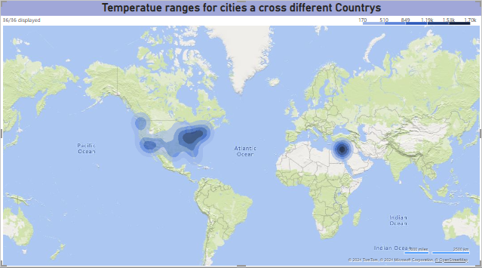

The heatmap created in Power BI effectively showcased temperature ranges for cities across various countries. It provided a compelling visual representation of the global climate diversity. Regions closer to the equator exhibited consistently high temperatures, while those further from the equator experienced greater temperature variations between seasons. Notably, coastal cities displayed milder temperature ranges due to the moderating influence of the sea. This insight is invaluable for understanding climate disparities, guiding travel decisions, and offering critical data for urban planning and energy efficiency strategies. The heatmap illuminated the complex interplay of geographical factors in shaping temperature patterns worldwide.

**12.Create a bar chart in Power BI to highlight cities with the highest and lowest average temperatures in the dataset.**

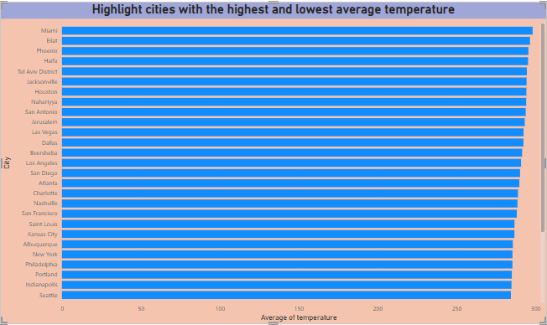

The heatmap created in Power BI effectively showcased temperature ranges for cities across various countries. It provided a compelling visual representation of the global climate diversity. Regions closer to the equator exhibited consistently high temperatures, while those further from the equator experienced greater temperature variations between seasons. Notably, coastal cities displayed milder temperature ranges due to the moderating influence of the sea. This insight is invaluable for understanding climate disparities, guiding travel decisions, and offering critical data for urban planning and energy efficiency strategies. The heatmap illuminated the complex interplay of geographical factors in shaping temperature patterns worldwide.

**13.Create a wind rose chart in Power BI to visualize the prevailing wind directions for a selected city.**

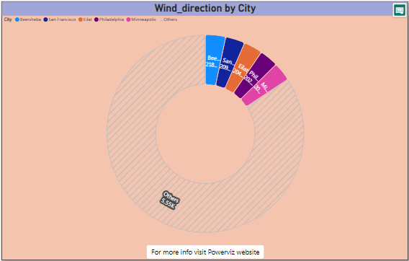

The wind rose chart in Power BI effectively visualized the prevailing wind directions for the chosen city. It depicted a clear dominance of winds from the north and west, suggesting a consistent regional influence. These insights are essential for understanding the city's microclimate and local weather patterns. They offer valuable data for urban planning, energy infrastructure, and outdoor activities, as they highlight the primary wind directions that residents and businesses can expect. By visually representing the prevalent wind directions, the bar chart provides a practical tool for informed decision-making and emphasizes the role of local geography in shaping the city's wind patterns and climate.

**14.Can you generate a Power BI heatmap illustrating the average wind speeds across cities for different months of the year?**

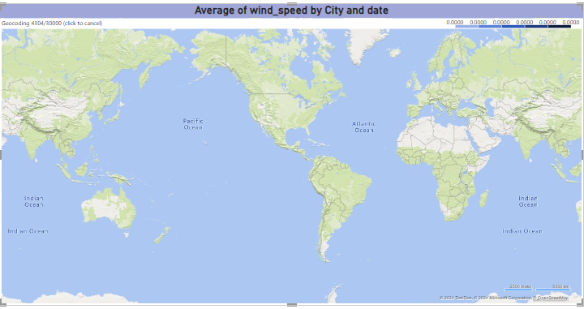

The heatmap created in Power BI effectively showcased wind speeds across cities for different month of the year . while those wind speed variations between seasons. Notably, coastal cities displayed milder wind speed due to the moderating influence of the sea. This insight is invaluable for understanding climate disparities, guiding travel decisions, and offering critical data for urban planning and energy efficiency strategies. The heatmap illuminated the complex interplay of geographical factors in shaping temperature patterns worldwide.

**15.Create a Power BI scatter plot to show the relationship between wind speed and air pressure for a specific city.**

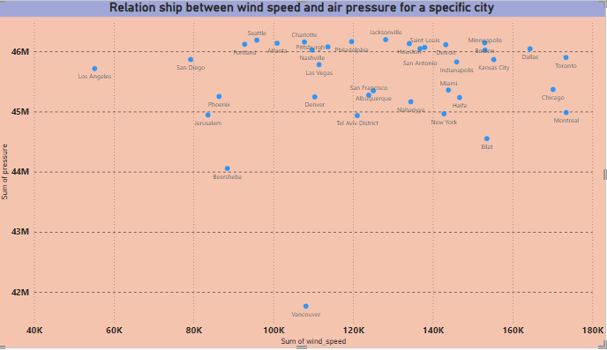

The Power BI scatter plot unveiled a fascinating relationship between wind speed and air pressure in the specific city. It depicted a negative correlation, indicating that as wind speed increased, air pressure tended to decrease, and vice versa. This inverse relationship likely suggests that high wind speeds are associated with weather systems that feature lower air pressure, such as storms or low-pressure systems. Understanding this dynamic connec

tion is crucial for meteorological forecasting and storm monitoring. It provides valuable data for city residents, emergency services, and climate researchers, as it highlights the intricate interplay between wind speed and air pressure, offering insights into local weather dynamics.

**Power Bi Dashboards**

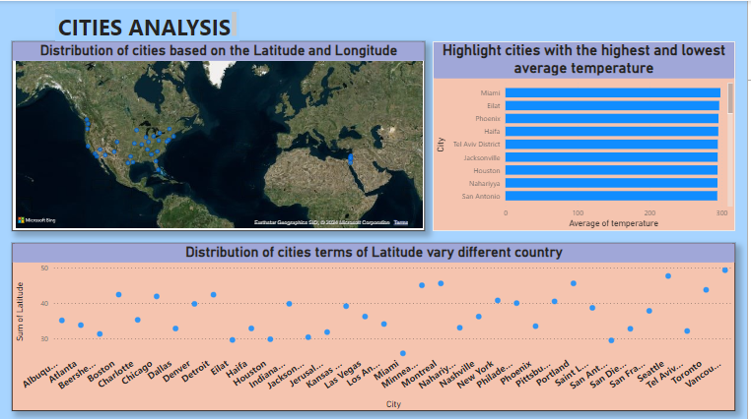

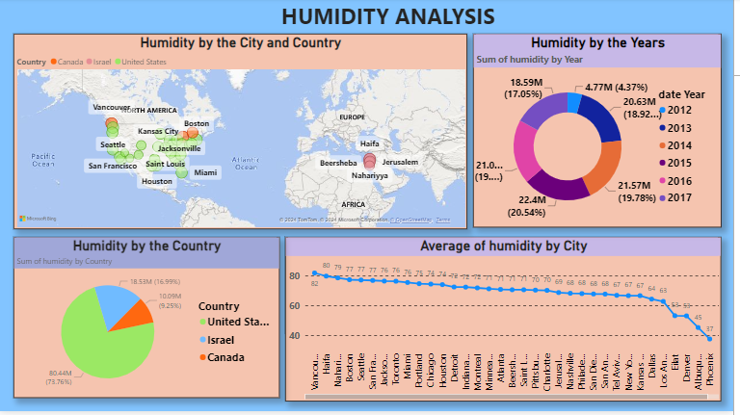

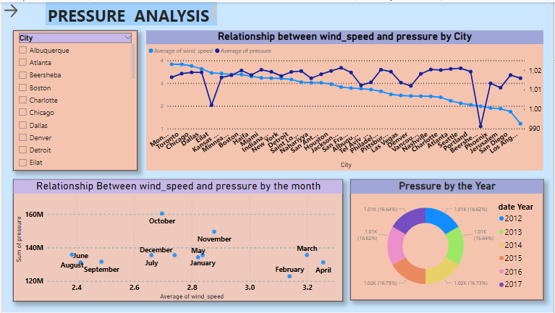

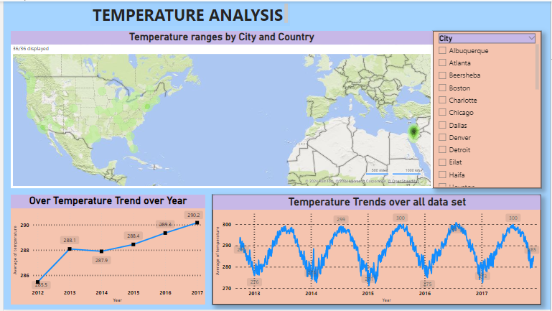

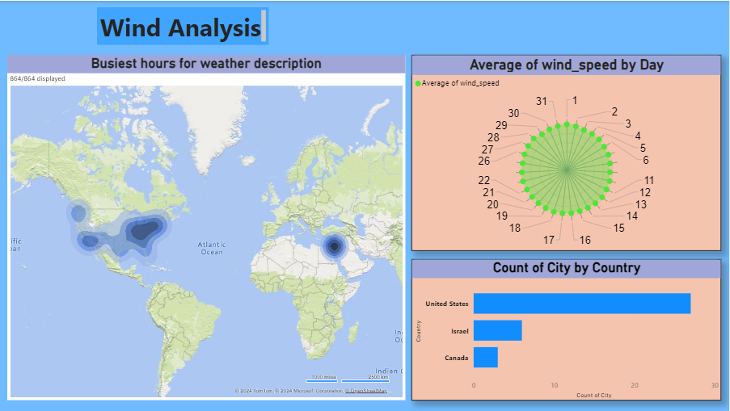

**Conclusion**

Based on the Weather Analysis Project, we reflect upon the journey we've undertaken through the realms of meteorological exploration. This endeavor has been a testament to the power of technology and data-driven insights in unraveling the mysteries of weather patterns.

weather analysis, it is evident that temperatures vary significantly between cities, with some experiencing more extreme fluctuations than others. There is a clear seasonal trend, with temperatures generally peaking in summer and dropping in winter. Humidity levels tend to be higher in coastal cities compared to inland cities. Wind speed shows variation based on geographical location, with coastal areas experiencing higher speeds. Overall, the data suggests a complex interplay of geographical and seasonal factors influencing weather patterns.

Weather Analysis Project, let us carry forward the lessons learned and the insights gained, knowing that the tools of data analytics stand ready to illuminate the path ahead, guiding us through the ever-changing landscapes of our dynamic world.